Java Course
Interfaces

Version 1.0

Topic Overview

This topic will introduce the use of Interfaces within the Java framework.

Topic Objectives

At the end of this topic you will be able to:

- Identify the difference between an Abstract class and an Interface within the Java framework as used in Java programming
- Describe why Interfaces are used within Java programming and in other programming languages
- Declare and use an Abstract class in an application
- Declare and use an Interface class in an application
- Amend code that has errors in the Interface design
- Amend code that has errors in the implementation of the Interface
- Declare and use multiple interfaces

Contents
Interfaces 5
Concept of an Interface 5
Concept of an Abstract Class 5
Lab One – Declaring and using an abstract class 7
Exercise One – Abstract Class 7
Declaring Interfaces 12
Implementing the Interface 12
Lab Two – Declaring and using an interface 14
Exercise One 14
Proper and improper declaration and use of interfaces 19
Lab Three 19
Exercise One – Not using the Interface in the class 19
Exercise Two – Trying to use a definition within an interface method 21
Lab Three 23
Exercise Three – Trying to create an interface and not use all methods 23
Lab Four – Declaring and using multiple interfaces 25
Exercise One 25
Lab Four – Declaring and using multiple interfaces 32
Exercise Two 32

Interfaces

Concept of an Interface
In the most simplistic form an interface can be defined as a ‘syntactical contract’ that all the classes inheriting the interface should follow. The interface defines the rules or patterns that form the contract or put another way it defines the 'what' part of the syntactical contract. Once we have this part of the contract then the class that derives from the interface must describe how the rules and patterns are to be implemented.
The interface will define the properties, methods and events, which are the members of the interface. Within an interface we can only declare the members. We do not define the members, that role belongs to the class that derives from the interface.

Concept of an Abstract Class
When we have created classes we have often instantiated the class but we can also use the class as a base class for other classes. The class therefore acts as a template or outline for the class that inherits it. In such circumstances the base class is called an abstract class.
As programmers we might want to create a base class that defines only a general format that will be used by all of derived classes. Since the information in the base class is only general it will be up to each derived class to add their own details

The abstract class therefore decides the nature of the methods that any derived classes must implement but it will not provide an implementation of any of the defined methods.
Abstract classes can therefore be defined as incomplete classes. Abstract classes have the following properties:
- they contain one or more incomplete methods called abstract methods.
- they provide the signature or declaration of the abstract methods (it will leave the implementation of these methods to derived or sub-classes).
- they are marked with the abstract keyword (as are abstract methods).
- they cannot be instantiated as they are incomplete.
- A class inheriting an abstract class must implement all the abstract methods in the abstract class, or it too must be declared as an abstract class.
- A class inheriting an abstract class and implementing all its abstract methods is called the concrete class of the abstract class.

Lab One – Declaring and using an abstract class

The code structure

ClaimsClass
(this will contain our Main method)
CarClaimsClass
(this will contain methods two of which have been used because the class extends the abstract class. The abstract class has 2 method signatures.
CarAbstractClass
(this will contain two method signatures, it therefore has 2 method signatures.

Exercise One – Creating an Abstract Class
- Open Eclipse.
- Create a workspace with the name required. I have used the name WorkspaceOOP1DayCourse.
- Click the Launch button.
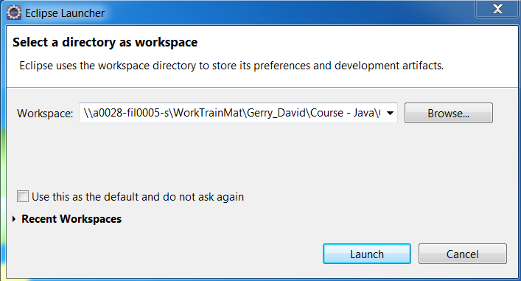
- Click on the File menu.
- Choose New.
- Choose Java Project (or choose the Other folder and then Java Project).
- Give the project a name. I have used the name OOPExamples.
- Right click on the src folder.
- Choose New.
- Choose Class.
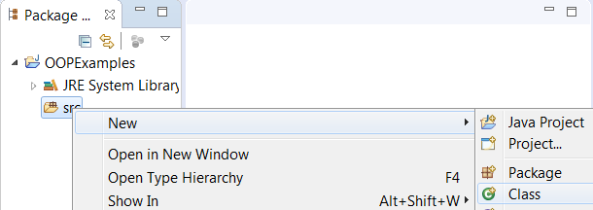
- Name the package gerry.abstractclass.
- Name the class ClaimAbstractClass.
- Ensure that the public static void main(String[] args) checkbox is unticked.
- Click the Finish button.
The code will be similar to that shown below:
package gerry.abstractclass;

public class ClaimAbstractClass
{

}

We will now add the abstract methods and in doing this we will need to make this class an abstract class.
- Amend the code as shown below:
package gerry.abstractclass;

//Start of abstract class called ClaimAbstractClass
public abstract class ClaimAbstractClass
{
abstract public void personaldetails();
abstract public void productdetails();
} // End of abstract class

Exercise Two – Creating a Class that uses the Abstract Class

We will now create a class that extends the abstract class ClaimAbstractClass. What this means is we will be creating a class that will extend the abstract class and will therefore have to have two methods called:
- personDetails
- productDetails
both of which are public void methods
- Right click on the src folder.
- Choose New.
- Choose Class.
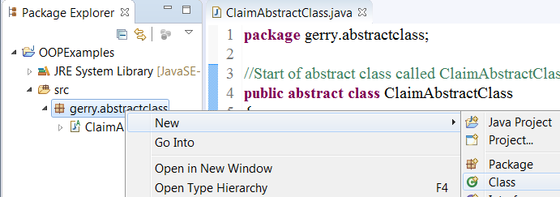
- Name the class CarClaimsClass.
- Ensure that the public static void main(String[] args) checkbox is unticked.
- Click the Finish button.
The code will be similar to that shown below:
package gerry.abstractclass;

public class CarClaimsClass
{

}

This is simply a class which is not tied (connected) to any other class. We will now extend the class by tying (connecting) it to the abstract class we have just created. In extending this class we will consequently have to implement the abstract methods.
- Amend the code as shown below:
package gerry.abstractclass;

public class CarClaimsClass extends ClaimAbstractClass
{

}
We have not actually implemented the abstract methods of the abstract class yet and we are therefore shown an error (a red line under the class name).
- Hover over the red line under the class name.
- Select the Add unimplemented methods option.

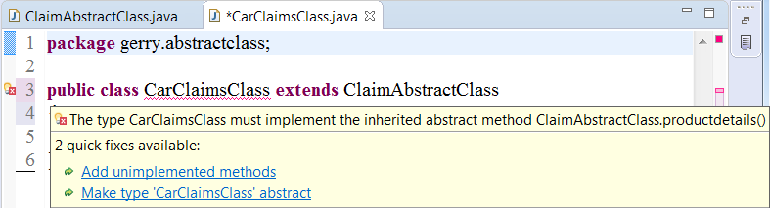
- Check that the 2 methods are now added to the class code as shown below:
package gerry.abstractclass;

public class CarClaimsClass extends ClaimAbstractClass
{

@Override
public void personaldetails() {
// TODO Auto-generated method stub

}

@Override
public void productdetails() {
// TODO Auto-generated method stub

}
}
This has now satisfied the contract between the abstract class and the class which extends it. We can see that we have added no code to the methods, this is fine, we were not told we had to. The contract said to have 2 methods with the public void and the correct names, nothing else. We have done that.
However we will more than likely want to add some business logic to the code.
- Amend the code again as shown below:

package introJava.Lesson16.AbstractClasses.February2018;

import java.util.Scanner;

//Start of class called HomeClaimClass which will use the
// ClaimAbstractClass as a template, that is, it will extend
// the abstract class
public class HomeClaimClass extends ClaimAbstractClass
{
// Creating Scanner instance to scan console for User input
static Scanner myScanner = new Scanner(System.in);

@Override
public void personaldetails()
{
System.out.println("******************* Client Personal Details *******************");
System.out.println("What is the name: ");
String clientName = myScanner.nextLine();
System.out.println("What is the address: ");
String clientAddress = myScanner.nextLine();
System.out.println("What is the DOB: ");
String clientDOB = myScanner.nextLine();
System.out.println("The details entered are: " + clientName + " - " + clientAddress + " - " + clientDOB);
System.out.println("*******************************************************");
}

@Override
public void productdetails()
{
System.out.println("******************* Client Product Details *******************");
System.out.println("What is the property type: ");
String propertyType = myScanner.nextLine();
System.out.println("What is the age of the property: ");
String propertyAge = myScanner.nextLine();
System.out.println("What is the value of the property: ");
String propertyValue = myScanner.nextLine();
System.out.println("The details entered are: " + propertyType + " - " + propertyAge + " - " + propertyValue);
System.out.println("*******************************************************");
}
}

Exercise Three – Creating a class with the main method
We will create a class with the main method. The class will have code that creates an instance of the CarClaimsClass and will therefore have access to the two methods. We should remember that the CarClaimsClass is an extension of the ClaimAbstractClass.

- Right click on the src folder or the package name.
- Choose New.
- Choose Class.
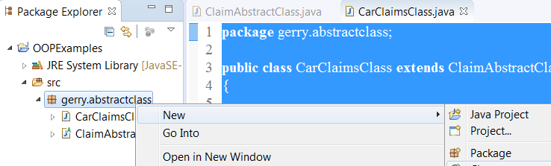
- Name the class ClaimsClass.
- Name the package gerry.abstractclasses.
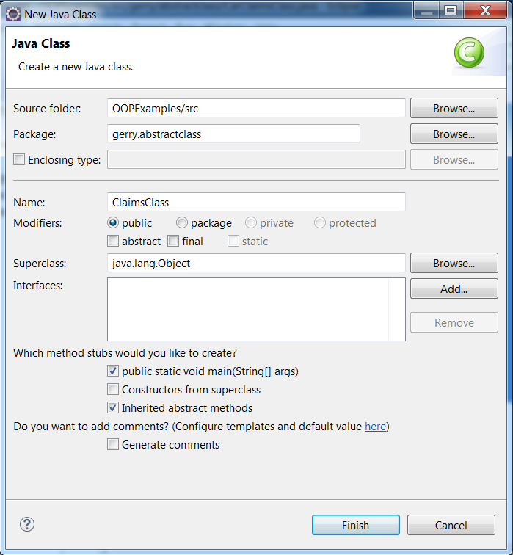
Class name
Package name
- Put a tick in the box beside public static void main(String[] args).
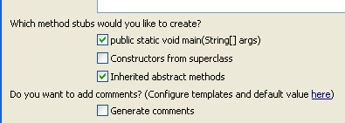
Tick here
- Click the Finish button.
The code will be similar to that shown below:
package gerry.abstractclass;

public class ClaimsClass
{
public static void main(String[] args)
{
// TODO Auto-generated method stub

}
}

- Amend the code as shown below.
System.out.println("We are now inside the main method of the class called ClaimsClass");
System.out.println("This is the class that uses the class with the 2 methods personaldetails()");
System.out.println("and productdetails()");
System.out.println("We will now instantiate the class called CarClaimClass so we can have");
System.out.println("access to the methods and properties within the class. In our example we");
System.out.println("have 2 methods which are public, ask a few questions and then display");
System.out.println("the information that was input");
System.out.println("*******************************************************");

CarClaimClass myInstanceOfCarClaimClass = new CarClaimClass();

System.out.println("We now call the personaldetails method declared in our CarClaimClass class");
System.out.println("Remember the CarClaimClass class extended the abstract class called ");
System.out.println("ClaimAbstractClass which had two abstract methods");
System.out.println("*******************************************");

myInstanceOfCarClaimClass.personaldetails();

System.out.println("*******************************************************");

myInstanceOfCarClaimClass.productdetails();

}
}
- Run the code.
- Answer the questions.
- Review the output.
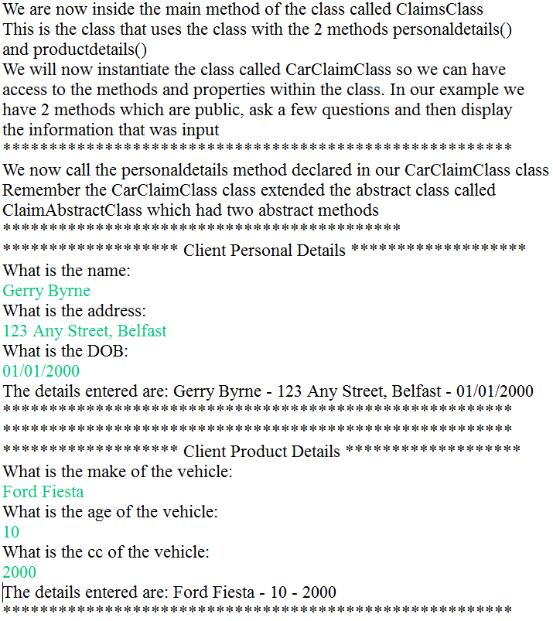
peronalDetails function
productDetails function

From the two descriptions of the interface and the abstract class above we could be forgiven for thinking that the abstract class and the interface have the same purpose. This is true but usually abstract classes are limited in that they are used to declare a couple of methods only.
Abstract classes versus Interface
- An Interface can only have abstract methods
An Abstract class can have abstract and non-abstract methods
From Java 8 the abstract class can have default and static methods as well
- Variables declared in a Java interface are by default final and will be static.
An abstract class may contain final, non-final static and non-static variables.
- A Java interface can be implemented using keyword “implements” while an abstract class can be extended using keyword “extends”.
- An interface can extend another Java interface only
an abstract class can extend another Java class and implement multiple Java interfaces
- Members of a Java interface are public by default
A Java abstract class can have class members like private, protected, etc

Declaring Interfaces
In declaring a class we use the Java keyword class. Similarly in declaring an interface we use the keyword interface. As a default an interface will be set to have an access modifier of public. The following code is an example of how an interface is declared:
package gerry.interfaces;

//Define an interface with its members
public interface ITransactions
{
// the interface members are declared
void showAllTransaction();
double getTransactionAmount();
}

Notice that
- the access modifier has been set to public
- the keyword interface has been used and
- the name of the interface has the prefix I (ITransactions).

Implementing the Interface
In implementing the interface we:
- Declare a class which implements the interface. In the example code below we declare a class called Transaction and say that it implements the interface ITransactions:

//Define a class that uses the interface
public class Transaction implements ITransactions
{

- Use the methods of the interface in the separate class that is implementing the interface. In the example code below we implement the interface members:
package gerry.interfaces;
import java.util.Date;
//Define a class that uses the interface
public class Transaction implements ITransactions
{
String transactionTaxCode;
Date transactionDate;
double transactionAmount;
@Override
public void showAllTransaction()
{
System.out.println("Transaction: \t " + transactionTaxCode);
System.out.println("Date: \t\t " + transactionDate);
System.out.println("Amount: \t " + getTransactionAmount());
}
@Override
public double getTransactionAmount()
{
switch (transactionTaxCode)
{
case "T1":
{
transactionAmount = transactionAmount / 1.2;
break;
}
case "T0":
case "T2":
case "T3":
case "T4":
case "T5":
case "T6":
case "T7":
case "T8":
case "T9":
{
transactionAmount = transactionAmount / 1.0;
break;
}
default:
{
transactionAmount = transactionAmount / 1.0;
break;
}
}
return transactionAmount;
}
}

Lab Two – Declaring and using an interface

Exercise One
This Java console application will create an interface and then implement the interface in a new class.
- Right click on the src folder.
- Choose New.
- Choose Interface.
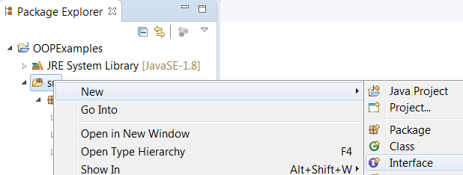
- Change the package name to gerry.interfacesclass
- Name the interface IClaims.
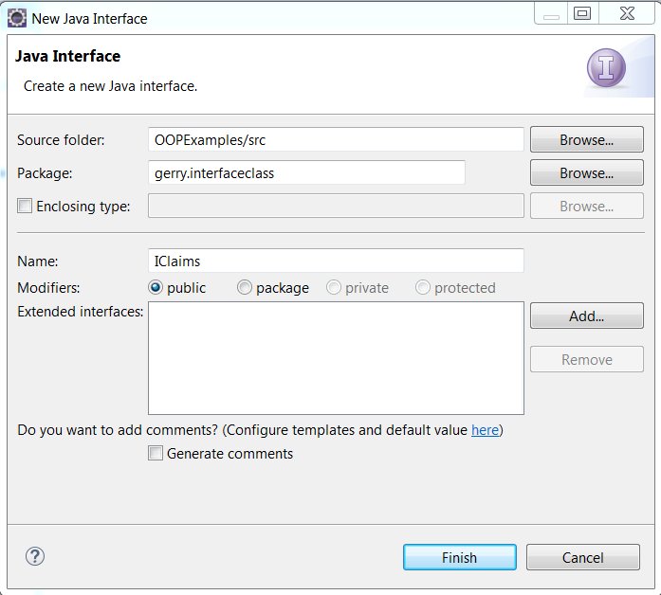
Interface name
- Click the Finish button.
The code will be similar to that shown below:

package gerry.interfaceclass;

public interface IClaims
{

}

- Amend the code as shown below to add the code (methods) for the interface:

package gerry.interfaceclass;

//Start of interface called IClaims
public interface IClaims
{
abstract public void personaldetails();
abstract public void productdetails();
} // End of Interface

- Click on the File menu.
- Choose Save All.
- Right click on the package.
- Choose New.
- Choose Class.

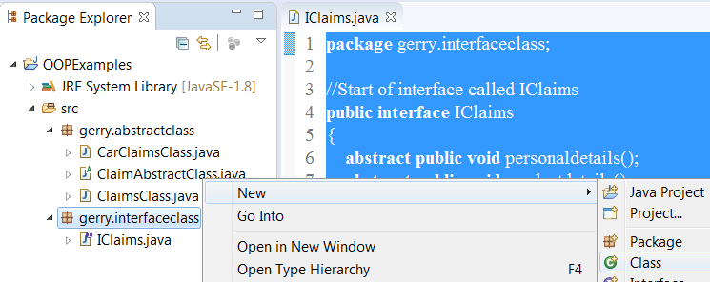

- Name the class CarClaimsClass.

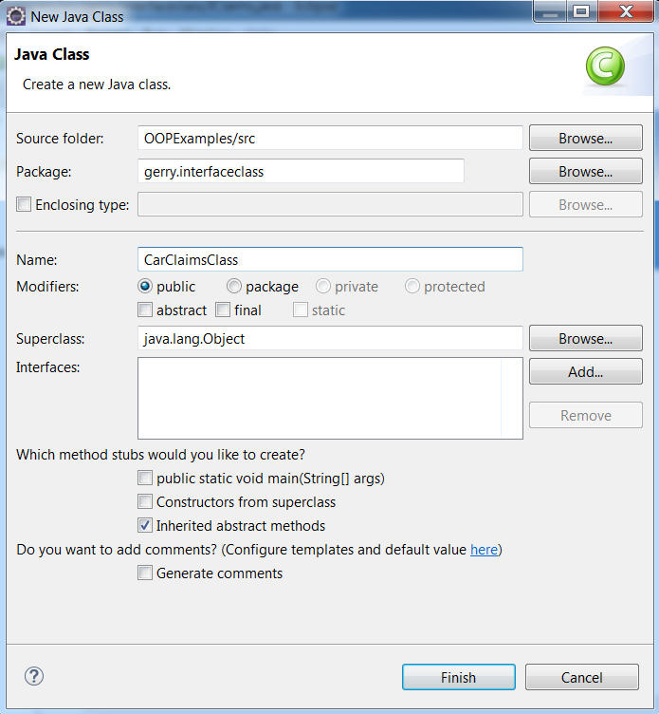

- Amend the code as shown below so that the class implements the IClaims interface

package gerry.interfaceclass;

public class CarClaimsClass implements IClaims
{

}

- Hover over the red line under the CarClaimsClass.
- Choose the Add unimplemented methods option.

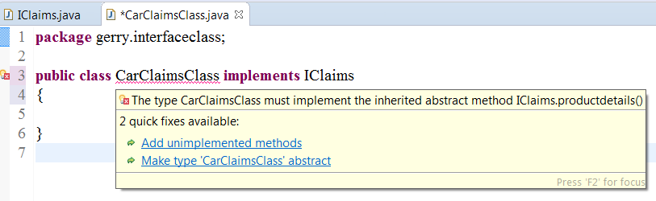

- Amend the code to add code (business logic) to the methods we have now implemented.

package gerry.interfaceclass;

import java.util.Scanner;

//Start of class called CarClaimClass which will use the
//IClaims interface as a template, that is, it will implement
//the interface
public class CarClaimsClass implements IClaims
{
// Creating Scanner instance to scan console for User input
static Scanner myScanner = new Scanner(System.in);

@Override
public void personaldetails()
{
System.out.println("******************* Client Personal Details *******************");
System.out.println("What is the name: ");
String clientName = myScanner.nextLine();
System.out.println("What is the address: ");
String clientAddress = myScanner.nextLine();
System.out.println("What is the DOB: ");
String clientDOB = myScanner.nextLine();
System.out.println("The details entered are: " + clientName + " - " + clientAddress + " - " + clientDOB);
System.out.println("*******************************************************"); }

@Override
public void productdetails()
{
System.out.println("******************* Client Product Details *******************");
System.out.println("What is the make of the vehicle: ");
String vehicleType = myScanner.nextLine();
System.out.println("What is the age of the vehicle: ");
String vehicleAge = myScanner.nextLine();
System.out.println("What is the cc of the vehicle: ");
String vehicleCC = myScanner.nextLine();
System.out.println("The details entered are: " + vehicleType + " - " + vehicleAge + " - " + vehicleCC);
}
}

- Amend the code to add another method that will calculate a quote based on the values entered for the product. (We will tidy the code to make it more modular at a later stage).

@Override
public void productdetails()
{
System.out.println("******************* Client Product Details *******************");
System.out.println("What is the make of the vehicle: ");
String vehicleType = myScanner.nextLine();
System.out.println("What is the age of the vehicle: ");
String vehicleAge = myScanner.nextLine();
System.out.println("What is the cc of the vehicle: ");
String vehicleCC = myScanner.nextLine();
System.out.println("The details entered are: " + vehicleType + " - " + vehicleAge + " - " + vehicleCC);
}

public double calculateQuote(String vehicleTypePassedIn, String vehicleAgePassedIn, String vehicleCCPassedIn)
{
double quoteAmount = 0.00;
double vehicleTypeFactor = 0.00;
double vehicleAgeFactor = 0.00;
double vehicleCCFactor = 0.00;

switch (vehicleTypePassedIn)
{
case "Ford":
{
vehicleTypeFactor = 1.2;
break;
}
case "Chrysler":
{
vehicleTypeFactor = 1.5;
break;
}
default:
{
vehicleTypeFactor = 2.0;
break;
}
}

switch (Integer.parseInt(vehicleAgePassedIn))
{
case 1:
{
vehicleAgeFactor = 1;
break;
}
case 2:
{
vehicleAgeFactor = 1.2;
break;
}
case 3:
{
vehicleAgeFactor = 1.3;
break;
}
case 4:
{
vehicleAgeFactor = 1.4;
break;
}
default:
{
vehicleAgeFactor = 2.0;
break;
}
}

if (Integer.parseInt(vehicleCCPassedIn) > 2000)
{
vehicleCCFactor = 1.5;
}
else
{
vehicleCCFactor = 1.0;
}

quoteAmount = 100 * vehicleTypeFactor * vehicleAgeFactor * vehicleCCFactor;

return quoteAmount;
} // End of calculateQuote method
} // End of class

- Amend the productDetails() method to pass the values into the calculateQuote() method.

@Override
public void productdetails()
{
System.out.println("******************* Client Product Details *******************");
System.out.println("What is the make of the vehicle: ");
String vehicleType = myScanner.nextLine();
System.out.println("What is the age of the vehicle: ");
String vehicleAge = myScanner.nextLine();
System.out.println("What is the cc of the vehicle: ");
String vehicleCC = myScanner.nextLine();
System.out.println("The details entered are: " + vehicleType + " - " + vehicleAge + " - " + vehicleCC);
System.out.println(calculateQuote(vehicleType, vehicleAge, vehicleCC));
}
- Click on the File menu.
- Choose Save All.
- Right click on the package.
- Choose New.
- Choose Class.
- Name the class ClaimsClass.
- Put a tick in the box beside public static void main(String[] args).
Tick here
- Click the Finish button.
- Amend the code for the class ClaimsClass as shown below use the class called CarClaimsClass that in turn uses the interface IClaims:

package gerry.interfaceclass;

public class ClaimsClass
{
public static void main(String[] args)
{
CarClaimsClass myCarClaims = new CarClaimsClass();

myCarClaims.personaldetails();
myCarClaims.productdetails();

}
}

- Click on the File menu.
- Choose Save All.
- Click on the Run button.

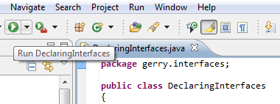
Run

- Enter some details, as shown below.

Look in the console window and you should see the output from the application as shown below:
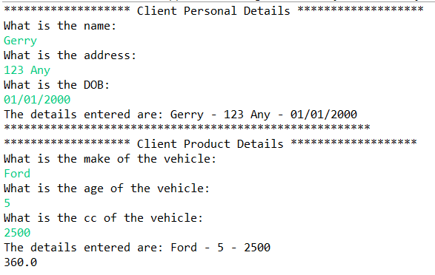

Proper and improper declaration and use of interfaces

Lab Three

Exercise One – Trying to use a definition within an interface method
This Java console application will use an interface with a method declared within it.

- Double click on the IClaims.java file to open it.
- Amend the code as shown below to add a method to the interface.
package gerry.interfaceclass;

//Start of interface called IClaims
public interface IClaims
{
abstract public void personaldetails();
abstract public void productdetails();

void method1InInterface()
{
System.out.println("method1InInterface cannot have a body just a declaration");
}

} // End of Interface

- Click on the File menu.
- Choose Save All.

Looking at the code we can see that an error has occurred and the red underscore is under the method name method1InInterface.

- Hover over the red line.
An error message will appear as shown below:

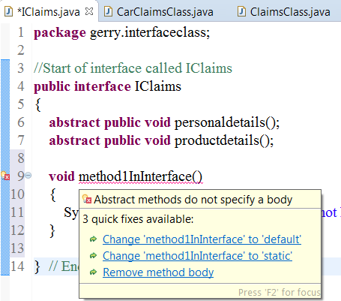

This clearly states that the method (abstract) cannot contain a body of code if it is in an Interface. It is the role of the implementing class to add the code it wants. The Interface should merely state that a method with this name must exist.

- Remove the method and ensure that our code looks that that shown below:

package gerry.interfaces;

public interface ITransactions
{
// the interface members are declared
void showAllTransaction();
double getTransactionAmount();
}

- Click on the File menu.
- Choose Save All.

Lab Three

Exercise Two – Trying to create an interface and not use all methods
This Java console application will use an interface and in it declare a method (with no body), but not implement the method in a class.

- Double click on the CarClaimsClass.java file to open it.
- Amend the code as shown below to comment out the CarClaimsClass:

package gerry.interfaceclass;

import java.util.Scanner;

//Start of class called CarClaimClass which will use the
//IClaims interface as a template, that is, it will implement
//the interface
public class CarClaimsClass implements IClaims
{
// Creating Scanner instance to scan console for User input
static Scanner myScanner = new Scanner(System.in);

// @Override
// public void personaldetails()
// {
// System.out.println("******************* Client Personal Details *******************");
// System.out.println("What is the name: ");
// String clientName = myScanner.nextLine();
// System.out.println("What is the address: ");
// String clientAddress = myScanner.nextLine();
// System.out.println("What is the DOB: ");
// String clientDOB = myScanner.nextLine();
// System.out.println("The details entered are: " + clientName + " - " + clientAddress + " - " + clientDOB);
// System.out.println("*******************************************************");
// }

- Click on the File menu.
- Choose Save All.

Looking at the code we can see that an error has occurred and the red underscore is under the Class name CarClaimsClass.

- Hover over the red line.
An error message will appear as shown below:

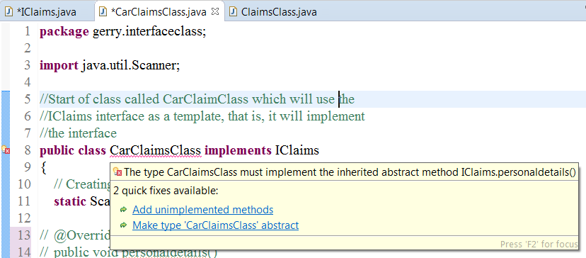

This clearly states that the personalDetails method (abstract) cannot be omitted from the implementing class code if it exists in the Interface. It is the role of the implementing class to add the code it wants to ALL methods. The Interface should merely state the method that must exist.

- Right click on the red underline.
- Choose the Add unimplemented methods option from the pop up message box by clicking on it.

The code will now have a fully working method called CarClaimsClass and the class has now fully implemented the Interface.
package gerry.interfaces;
public class ProperImproperV1 implements ITransactions
{
public static void main(String[] args)
{
System.out.println("We have not used the Interface");
System.out.println();
}
public void showAllTransaction()
{
System.out.println("Show All Transaction Method is implemented by this line");
}
@Override
public double getTransactionAmount()
{
// TODO Auto-generated method stub
return 0;
}
}
- Delete this newly created method.
- Uncomment the original personalDetails method.
- Click on the File menu.
- Choose Save All.

Lab Four – Declaring and using multiple interfaces

Exercise One
This Java console application will create a class that implements multiple interfaces.

- Right click on the package.
- Choose New.
- Choose Interface.
- Name the class IStoreData.
- Click the Finish button.
- Amend the code as shown below:

package gerry.interfaces;

public interface IStoreData
{
// The interface has no access modifiers by default they are public
// The interface has no implementation of the methods or property
void ReadData();
void WriteData(String obj);

int getFileStatus();

void setFileStatus(int FileStatus);
}

- Click on the File menu.
- Choose Save All.

This has created an Interface called IStoredata with two methods:
- ReadData()
- WriteData(String obj)
and a getter and setter method:
- getFileStatus() and setFileStatus() (which are of type int)

There is no implementation for the get and set. They simply state that there is a get and a set. We will now amend the code so that a new class FileExample Implements the IStoredata interface.

- Right click on the package.
- Choose New.
- Choose Class.
- Name the class FileExample.
- Ensure that there is no tick in the checkbox beside Main.
- Click the Finish button.
- Amend the code as shown below to make the class implement the interface we have just created

package gerry.interfaces;

public class FileExample implements IStoreData
{
int FileStatus = 0;

public FileExample(String s)
{
System.out.printf("Creating document with: " + s);
}
}

- Click on the File menu.
- Choose Save All.

Looking at the code we can see that an error has occurred and the red underscore is under the class name FileExample.

- Hover over the red line. An error message will appear as shown below:
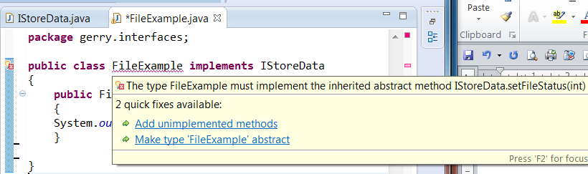
- Right click on the red underline.
- Choose the Add unimplemented methods option from the pop up message box by clicking on it.

The code will now have a fully working implementation of the IStoreData Interface. We now have methods for:
ReadData()
WriteData()
getFileStatus()
setFileStatus()
as shown below:
package gerry.interfaces;
public class FileExample implements IStoreData
{
int FileStatus = 0;

public FileExample(String s)
{
System.out.printf("Creating document with: " + s);
}
@Override
public void ReadData() {
// TODO Auto-generated method stub
}

@Override
public void WriteData(String obj) {
// TODO Auto-generated method stub
}

@Override
public int getFileStatus() {
// TODO Auto-generated method stub
return 0;
}

@Override
public void setFileStatus(int FileStatus) {
// TODO Auto-generated method stub
}
}
- Amend the file as shown below to add code to the methods.
package gerry.interfaces;

public class FileExample implements IStoreData
{
public FileExample(String s)
{
System.out.printf("Creating document with: " + s);
}

@Override
// This method implements the ReadData method and simply writes an output line
public void ReadData()
{
System.out.println("We have Implemented the ReadData Method for IStoredata");
}

@Override
// This method implements the WriteData method and simply writes an output line
public void WriteData(String obj)
{
System.out.println("We have Implemented the WriteData Method for IStoredata");
}

@Override
public int getFileStatus()
{
// TODO Auto-generated method stub
return FileStatus;
}

@Override
public void setFileStatus(int newFileStatus)
{
// TODO Auto-generated method stub
FileStatus = newFileStatus;
}
}
- Right click on the package.
- Choose New.
- Choose Class.
- Name the class MultipleInterfaces.
- Put a tick in the box beside public static void main(String[] args).
Tick here
- Click the Finish button.
- Amend the code for the class MultipleInterfaces as shown below. This class uses the FileExample class which uses the IStoreData interface.
package gerry.interfaces;
public class MultipleInterfaces
{
public static void main(String[] args)
{
// access the methods in the Document object
FileExample myFile = new FileExample("Test input data from MultipleInterfaces class\n");

// Write out the value of the FileStaus integer variable
// before amending it or setting its value
System.out.println("Document Status: " + myFile.FileStatus);

// This code sets the value for the FileStatus property.
//myFile.FileStatus = 5;
myFile.setFileStatus(5);

// Use the ReadData method
myFile.ReadData();

// Write out the value of the FileStaus integer variable
System.out.println("Document Status: " + myFile.FileStatus);
}
}
It is the role of the implementation (the class that implements the Interface) to declare the variables. Interfaces should really only contain constants if they are relevant to the rest of the interface.

- Click on the Run button.
Run
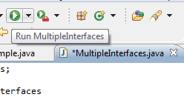
- If you are asked to save the code file click on the OK button.

Look in the console window and you should see the output from the application as shown below:
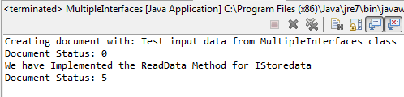
Analysis:
- The MultipleInterfaces class we have created starts with the main method
- An instance of the FileExample class is created and we pass in a string as the object
- The FileExample class has a constructor with the same name which writes a line of text and uses the string that has been passed in
- The console will now have the line of text “Creating document with : Test input data from MultipleInterfaces class”
- None of the rest of the methods are invoked
- The console window will now show the current value of FileStatus as we have FileStatus property in our print line
- In the main method the FileStatus is set to 5
- Then the ReadData file is called and this writes a line of text
- The console will now have the line of text “We have Implemented the ReadData Method for IStoredata”
- Finally the main method writes a line of text and the console will now have the line of text “Document Status: 5”

Points
- The IStoredata method declarations do not include access modifiers (e.g. public, protected, internal, private)
- Using an access modifier generates a compile error
- Interface methods are implicitly public because an interface is a contract meant to be used by other classes
- We cannot create an instance of an interface. Instead we can instantiate a class that implements the interface
- The class implementing the interface must fulfill the contract exactly and completely
- FileExample must provide both a ReadData( ) and a WriteData( ) and the other 2 methods getFileStatus() and setFileStatus()
- How FileExample meets these necessities is entirely up to the class

Lab Four – Declaring and using multiple interfaces

Exercise Two
This Java console application will build on the last example and will create another interface and a new class will implement both interfaces.

All classes can implement more than one interface e.g. our FileExample class could implement both an IStorable and an ICompressed interface. In order that this can be achieved we have to amend the declaration to specify that both interfaces are implemented. The two interface names are separated with commas:
public class FileExample implements IStoredata, ICompressed

Now that we have made this declaration FileExample must implement the methods specified by the
ICompressed interface as well as the IStoredata interface.

- Right click on the package.
- Choose New.
- Choose Interface.
- Name the class ICompressed.
- Click the Finish button.
- Amend the code as shown below:
package gerry.interfaces;

public interface ICompressed
{
void Compress();
void Decompress();
}

- Click on the File menu.
- Choose Save All.

This has created an Interface called ICompressed with two methods:
- Conpress()
- Decompress()
We will now amend the code so that the class FileExample Implements the IStoredata and ICompressed interfaces.

- Double click on the FileExample class in the Package Explorer.
- Amend the code as shown below to make the class implement the two interfaces (IStoreData and ICompressed) we have just created

package gerry.interfaces;

public class FileExample implements IStoreData, ICompressed
{
int FileStatus = 0;

- Hover over the red line under the class name, FileExample.

The error message will appear and we will be told that the FileExample class must implement the methods of the Interfaces.
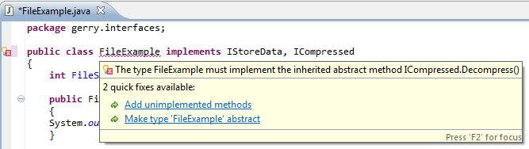

- Click on the Add unimplemented methods hyperlink in the error message box.

The two methods from the ICompressed interface will be added to our class.
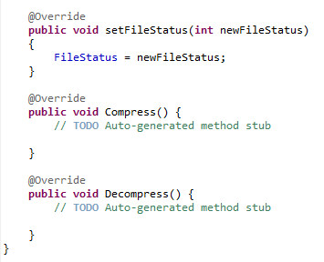
We will now add code to these methods.

- Amend the code as shown below to make the method print out a message:
@Override
public void setFileStatus(int newFileStatus)
{
FileStatus = newFileStatus;
}

@Override
// This method implements the Compress method and simply writes an output line
public void Compress()
{
// TODO Auto-generated method stub
System.out.println("Implementing the Compress method of the ICompressed Interface");
}

- Amend the code as shown below to make the method print out a message:
@Override
// This method implements the Compress method and simply writes an output line
public void Compress()
{
// TODO Auto-generated method stub
System.out.println("Implementing the Compress method of the ICompressed Interface");
}

@Override
// This method implements the Decompress method and simply writes an output line
public void Decompress()
{
// TODO Auto-generated method stub
System.out.println("Implementing Decompress method of the ICompressed Interface");
}
}

- Click on the File menu.
- Choose Save All.
- Amend the code for the class MultipleInterfaces as shown below. This class uses the FileExample class which uses the IStoreData and ICompressed interfaces
package gerry.interfaces;
public class MultipleInterfaces
{
public static void main(String[] args)
{
// access the methods in the Document object
FileExample myFile = new FileExample("Test input data from MultipleInterfaces class\n");

// Write out the value of the FileStaus integer variable
// before amending it or setting its value
System.out.println("Document Status: " + myFile.FileStatus);

// This code sets the value for the FileStatus property.
//myFile.FileStatus = 5;
myFile.setFileStatus(5);

// Use the ReadData method
myFile.ReadData();

// Use the Compress method
myFile.Compress();

// Use the Decompress method
myFile.Decompress();

// Write out the value of the FileStaus integer variable
System.out.println("Document Status: " + myFile.FileStatus);
}
}

- Click on the File menu.
- Choose Save All.
- Click on the Run button.
Run
- If you are asked to save the code file click on the OK button.

Look in the console window and you should see the output from the application as shown below:
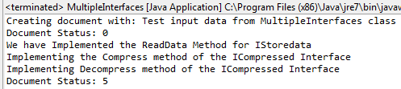
Analysis:
- In the main method the FileStatus is set to 5
- The Compress method is invoked and the console has the appropriate message
- The Decompress method is invoked and the console has the appropriate message

We have therefore used a class that implements more than one interface

